**NAME – KARAN DAS**

**USER ID – 34763**

**MAIL-** [**karannnx20@gmail.com**](mailto:karannnx20@gmail.com)

**Date – 6th Aug 2025**

**Topic Assignment:**

1. Using Windows Tools for Debugging.

2. Steps to create for Microsoft intune portal .

**Practice activity:**

**1. Using Windows Tools for Debugging.**

* Autologon :-

automates user logins.

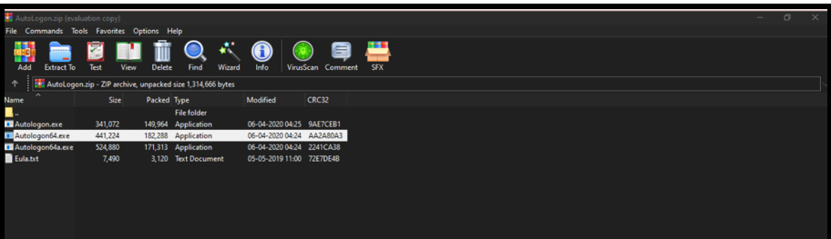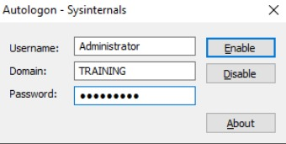

* Process Explorer:-

provides detailed process information.

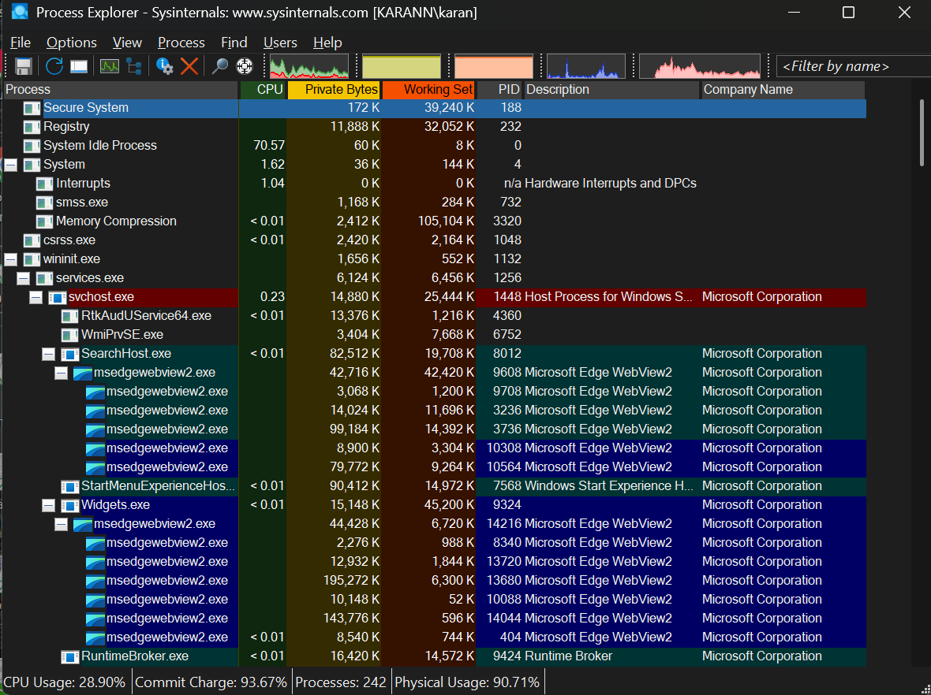

* Process Monitor :- Process Monitor is a powerful system monitoring tool used to track and analyze real-time activities of the file system, registry, and processes in Windows.

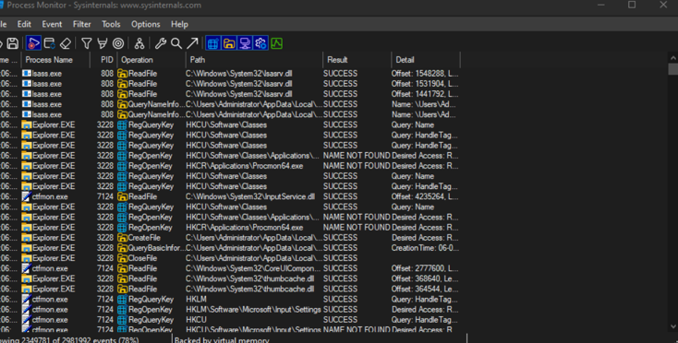

* PsExec :-

enables remote execution of commands and programs.

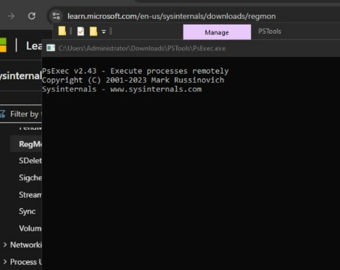

* PSTools:-

helps manage logon sessions.

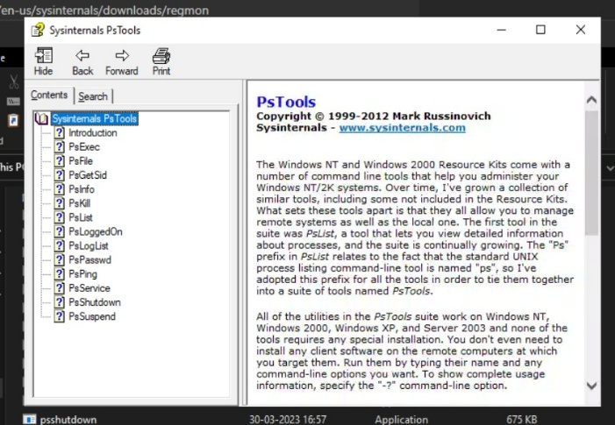

* RegMon :-

monitors registry activity.

* Sysmon :-

provides system-level monitoring.

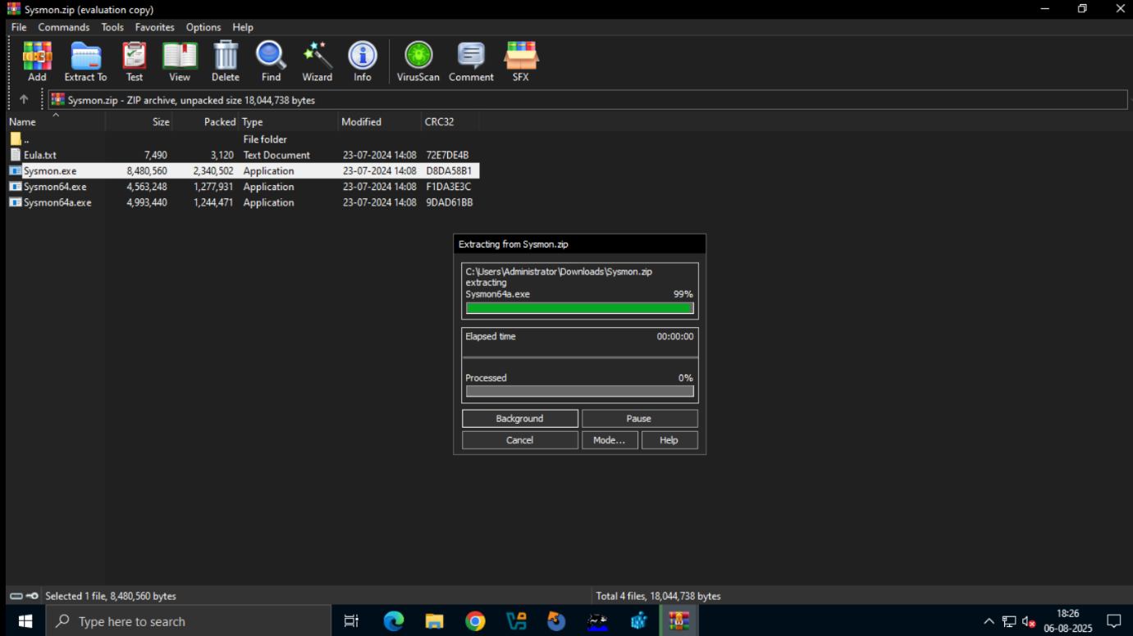

* Whois :-

is useful for network information.

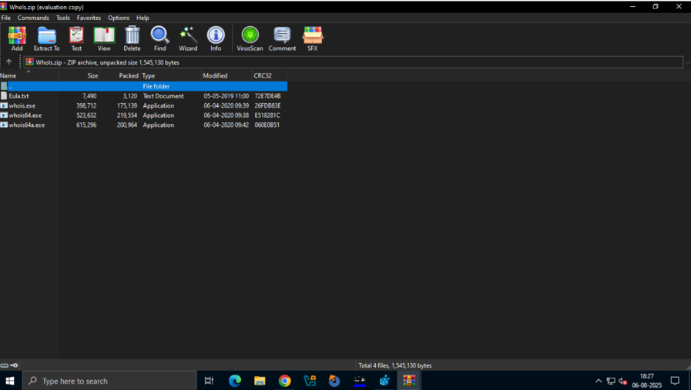

**2. Steps to create for Microsoft intune portal.**

1.Sign In  
Go to https://intune.microsoft.com and sign in with a Global Admin account.

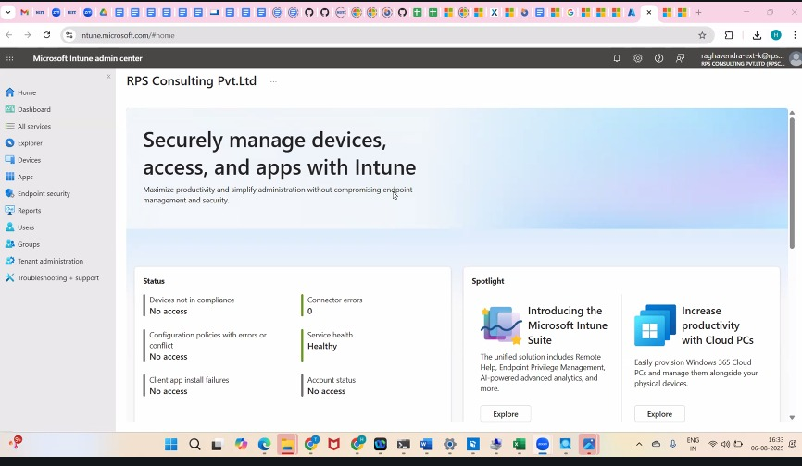

2.Assign Intune License  
In Microsoft 365 Admin Center → Users → assign Intune license to users.

3.MDM Authority  
In Intune Admin Center → Tenant Administration → set Microsoft Intune as MDM authority.

4.Enroll Devices  
Go to Devices → Enroll Devices, set up platform-specific enrollments (Windows, Android, iOS).

5. Create Policies

* Compliance Policy (e.g., password rules, OS version)
* Configuration Profile (e.g., Wi-Fi, security, Defender settings)

6. Add Apps  
Go to Apps → All Apps → Add, upload or select apps, assign to users/devices.

7. Monitor  
Use the Monitor section to track device health, app deployments, and compliance.